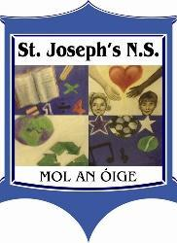

Calendar for the 2026 – 2027 School Year
TERM 1
School Year Begins | Thurs 27th Aug
Mid-Term Break | Fri 23rd Oct
School Reopens | Mon 2nd Nov
Christmas Holidays | Tues 22nd Dec
TERM 2
School Reopens | Wed 6th Jan 2027
St. Brigid's Day | Mon 1st Feb
Mid-Term Break | Thurs 18th Feb & Fri 19th Feb
School Reopens | Mon 22nd Feb
St. Patrick's Day | Wed 17th Mar
School Reopens | Thurs 18th Mar
Easter Holidays | Fri 19th March
TERM 3
School Reopens | Mon 5th Apr
May Bank Holiday Mid Term | 3rd - 7th May
School Reopens | Mon 10th May
June Bank Holiday | Mon 7th June
Summer Holidays | Fri 25th June

